Documentation for
Model Reduction Routines for MATLAB
Copyright (C) 2006-2012: Chuili Sun, Juergen Hahn
Department of Biomedical Engineering
Department of Chemical & Biological Engineering
Rensselaer Polytechnic Institute
Troy, NY
USA
hahnj@rpi.edu

Introduction

Balancing is an important approach for model reduction of controlled systems which consists of two steps: the first step is to find a transformation that balances the controllability and observability gramians [1] in order to determine which states have the greatest contribution to the input-output behavior. The next step is to perform a Galerkin projection onto the states corresponding to the largest singular values of the balanced gramians for the region of interest in state-space [2]. In order to perform model reduction via balancing, three components are required: a controllability gramian, an observability gramian, and a transformation matrix which balances the system. For control-affine nonlinear systems, it is possible to compute empirical gramians instead of linear gramians. For general nonlinear systems, covariance matrices should be used. The MATLAB code presented on this web page includes routines for computing empirical gramians or covariance matrices and a routine for computing the transformation matrix that balances the system. The algorithms used to compute these quantities were presented in [3, 4]. Detailed descriptions of these routines are presented along with the code. Additionally, several examples are given as a demonstration on how to use these routines.

Descriptions of routines

Routine for computing controllability gramian or covariance matrix
function yhat = ctrl_gram_cov (OdeFcn, Tspan, ParaVector, Cm, flag)
This function computes the controllability gramian or the controllability covariance matrix for stable dynamical systems by making use of data collected along system trajectories. To use this function, the following input arguments are required:
OdeFcn: the ode function of the system written by MATLAB. The form can be: Function xdot = OdeFcn(t, x)
Tspan: [start time, end time, sampleLength], which is used for integration of the OdeFcn. The end time should be long enough for the system to get close to a steady state.
ParaVector: system parameters, including InputNumber p, StateNumber n, OutputNumber k, Orientation Number r (generally r=2) and length q
Cm: CmValue, and s = size(Cm), the perturbation size of inputs.
flag == 0, gramian; flag ~= 0, covariance matrix
The output argument yhat represents the controllability gramian (flag = 0) or the controllability covariance matrix (flag ~= 0)
This routine applies impulse input perturbations for computing empirical controllability gramians or applies step input perturbations for computing controllability covariance matrices.

Routine for computing observability gramian or covariance matrix
function xhat = obsv_gram_cov (OdeFcn, Tspan, ParaVector, Cm, OutputIndex, xss, flag)
This function computes the observability gramian or observability covariance matrix for stable dynamical systems by making use of data collected along system trajectories. To use this function, the following input arguments are required:
OdeFcn: the ode function of the system written by MATLAB. The form can be: Function xdot = OdeFcn(t, x)
Tspan: [start time, end time, sampleLength], which is used for integration of the OdeFcn. The end time should be long enough for the system to get close to a steady state. This value can be estimated by simulating the system and checking how long it takes to reach the steady state.
ParaVector: system parameters, including InputNumber p, StateNumber n, OutputNumber k, Orientation Number r (generally r=2) and length q
Cm: CmValue, and s = size(Cm), the perturbation size of inputs.
OutputIndex: the indices of output corresponding to states. Here, assume the outputs are one or more of the state exactly, for instance, if there is one output which is the first state, then the OutputIndex is 1. And if there are two outputs, one output is the first state and the other is the fifth state, then the OutputIndex term should be [1 5].
xss: the initial condition of the states.
flag == 0, gramian; flag ~= 0, covariance matrix.
The output argument xhat represents the observability gramian (flag = 0) or covariance matrix (flag ~= 0)
This routine applies initial condition perturbations in each state to compute the empirical observability gramian or the observability covariance matrix.

Routines for unscaled systems
Routine 1 and 2 are designed to compute gramians or covariance matrices for scaled systems. For unscaled systems, the following two routines can be used:
function yhat = ctrl_gram_cov_unscaled (OdeFcn, Tspan, ParaVector, Cm, uss, xss, flag)
function xhat = obsv_gram_cov_unscaled (OdeFcn, Tspan, ParaVector, Cm, OutputIndex, uss, xss, flag)
The only difference between the routines for scaled systems and unscaled systems lies in the input arguments. For ctrl_gram_cov_unscaled, uss and xss are needed which represent the input values at steady state and the initial conditions. For obsv_gram_cov_unscaled, uss and xss are also needed.

Routine for computing the transformation matrix for balancing
function [Trans, invTrans, Wc, Wo, svd_Wc, svd_Wo] = bal_realization(yhat, xhat, n)
This function computes the transformation matrix that balances the system and also computes the balanced gramians (or the balanced covariance matrices) and the Hankel singular values, when the controllability and observability gramian or covariance matrix are known. The input argument yhat represents the (empirical) controllability gramian or covariance matrix, xhat refers to the (empirical) observablility gramian or covariance matrix, and n is the number of states. The output arguments are as follows:
Trans: the transformation matrix
invTrans: the inverse of the transformation matrix
Wc: balanced controllability gramian/covariance matrix
Wo: balanced observability gramian/covariance matrix
svd_Wc: singular values
svd_Wo: singular values

Model reduction procedure

Compute necessary quantities for model reduction
Gramians (or covariance matrices) and the transformation transformation are required for balanced model reduction. These quantities can be computed by use of the above mentioned routines. The routines for unscaled systems are mainly for verifying these routines by comparison against the MATLAB commands for linear systems. In practice, the routines for scaled systems are applied as it needs to be taken into account that a state changing by orders of magnitude can be more important than a state which hardly changes, even though its steady state may have a smaller absolute value. One important problem to discuss here is how a scaled system is obtained.
For a general nonlinear system
$$\begin{aligned}\overset{˙}{x}=f(x,u) \\ y=g(x,u)\end{aligned}$$
Let $x_{\text{ss}}$, $u_{\text{ss}}$represent the steady state values of x and u. Introduce two quantities: $T_{x}=\text{diag}(x_{\text{ss}})$and $T_{u}=\text{diag}(u_{\text{ss}})$, then the scaled system is:
$$\begin{aligned}\left.\overset{˙}{x}=f(x,u) | \right\}\end{aligned}\vec{\tilde{x}=T_{x^{−1}}x,\tilde{u}=T_{u^{−1}}}\begin{aligned}\left\{\tilde{\overset{˙}{x}}=T_{x^{−1}}f(T_{x}\tilde{x},T_{u}\tilde{u}) | \right.\end{aligned}$$

Balanced system
With the balancing transformation matrix T (= “Trans”), the balanced system is given by:
$$\begin{aligned}\left.\overset{˙}{x}=f(x,u) | \right\}\end{aligned}\vec{\bar{x}=\text{Tx}}\begin{aligned}\left\{\bar{\overset{˙}{x}}=\text{Tf}(T^{−1}\bar{x},u) | \right.\end{aligned}$$
Generally the scaled system is used for the computation of T resulting in:
$$\begin{aligned}\left.\tilde{\overset{˙}{x}}=T_{x^{−1}}f(T_{x}\tilde{x},T_{u}\tilde{u}) | \right\}\end{aligned}\vec{\bar{x}=T\tilde{x}}\begin{aligned}\left\{\bar{\overset{˙}{x}}={\text{TT}}_{x^{−1}}f(T_{x}T^{−1}\bar{x},T_{u}\tilde{u}) | \right.\end{aligned}$$

Model reduction implementation
After obtaining a balanced system, it needs to be determined how many states can be reduced and which reduction method to use. The former problem can be solved by a trial and error procedure while taking into account the magnitude of the Hankel singular values of the states to be reduced. The answer to the latter question is that balanced truncation is the method of choice for nonlinear systems as other techniques, e.g. balanced residualization, can lead to systems which may be smaller but significantly harder to solve.
The state vector of a balanced system can be divided into two parts: relatively important states ${\bar{x}}_{1}$ and relatively unimportant states ${\bar{x}}_{2}$. The reduced model is:
$\begin{aligned}{\bar{\overset{˙}{x}}}_{1}=\text{PTf}(T^{−1}\bar{x},u) \\ {\bar{\overset{˙}{x}}}_{2}={\bar{x}}_{2\text{ss}} \\ y=g(T^{−1}\bar{x},u)\end{aligned}$ where P =[I_{k} 0], k is the number of retained states.
Or for the scaled system, the reduced model is:
$$\begin{aligned}{\bar{\overset{˙}{x}}}_{1}={\text{PTT}}_{x^{−1}}f(T_{x}T^{−1}\bar{x},T_{u}\tilde{u}) \\ {\bar{\overset{˙}{x}}}_{2}={\bar{\overset{˙}{x}}}_{2\text{ss}} \\ y=g(T_{x}T^{−1}\bar{x},T_{u}\tilde{u})\end{aligned}$$

Demonstration examples

Several case studies are presented in this documentation. The procedure is mainly demonstrated on the first example and lesser detail is provided for the remaining two examples.

Example 1: a linear system
This example is included to show that the presented method will simplify to linear balanced truncation if the system under study is linear. Also, this example can be used to illustrate the procedure.

Model description and input arguments determining
$$\begin{aligned}\overset{˙}{x}=\text{Ax}+\text{Bu}\begin{matrix}, & & x∈ℜ^{n}\end{matrix} \\ y=\text{Cx}+\text{Du}\end{aligned}$$
where, $A=\begin{aligned}\left[\text{ -2}\text{.}\text{0000 0 0} | \right]\left[\text{ 1}\text{.}\text{0000 -1}\text{.}\text{1000 0} | \right] \\ \end{aligned}$ , $B=\begin{aligned}\left[\text{ 2} | \right]\left[\text{ 0} | \right] \\ \end{aligned}$
$C=\left[\text{0 0 1}\right]$, $D=[0]$
If the initial value for input $u_{\text{ss}}$ = 2, then $x_{\text{ss}}=−A^{−1}{\text{Bu}}_{\text{ss}}=\begin{aligned}\left[\text{ 2}\text{.}\text{0000} | \right]\left[\text{ 1}\text{.}\text{8182} | \right] \\ \end{aligned}$. Therefore, the quantities for scaling the system are: $T_{x}=\text{diag}(x_{\text{ss}})=\begin{aligned}\left[\text{ 2}\text{.}\text{0000 0 0} | \right]\left[\text{ 0 1}\text{.}\text{8182 0} | \right] \\ \end{aligned}$and $T_{u}=\text{diag}(u_{\text{ss}})=[2]$.
The scaled system is then given by
$\tilde{A}=T_{x}^{−1}{\text{AT}}_{x}=\begin{aligned}\left[\text{ -2}\text{.}\text{0000 0 0} | \right]\left[\text{ 1}\text{.}\text{1000 -1}\text{.}\text{1000 0} | \right] \\ \end{aligned}$ , $\tilde{B}=T_{x}^{−1}{\text{BT}}_{u}=\begin{aligned}\left[\text{ 2} | \right]\left[\text{ 0} | \right] \\ \end{aligned}$
$\tilde{C}={\text{CT}}_{x}=\left[\text{ 0 0 0}\text{.}\text{1818}\right]$, $\tilde{D}=[0]$
The code to obtain the scaled system from the unscaled system is:

-----------------------------------------------------------
tx = diag(xss);
tu = diag(uss);
abar = inv(tx)*A*tx;
bbar = inv(tx)*B*tu;
cbar =C*tx;
dbar = [0];
sysbar = ss(abar,bbar,cbar,dbar);
-----------------------------------------------------------

This system has 1 input, 1 output, and3 states. Therefore, p = 1, n = 3, k = 1. Select r = 2, q = 1000. Then “ParaVector” = [1 3 1 2 1000]. uss = 2, xss = [2.0 1.8182 0.1818]^{T}, and “OutputIndex” = 3.

The step response of this system is shown as Fig. 1.
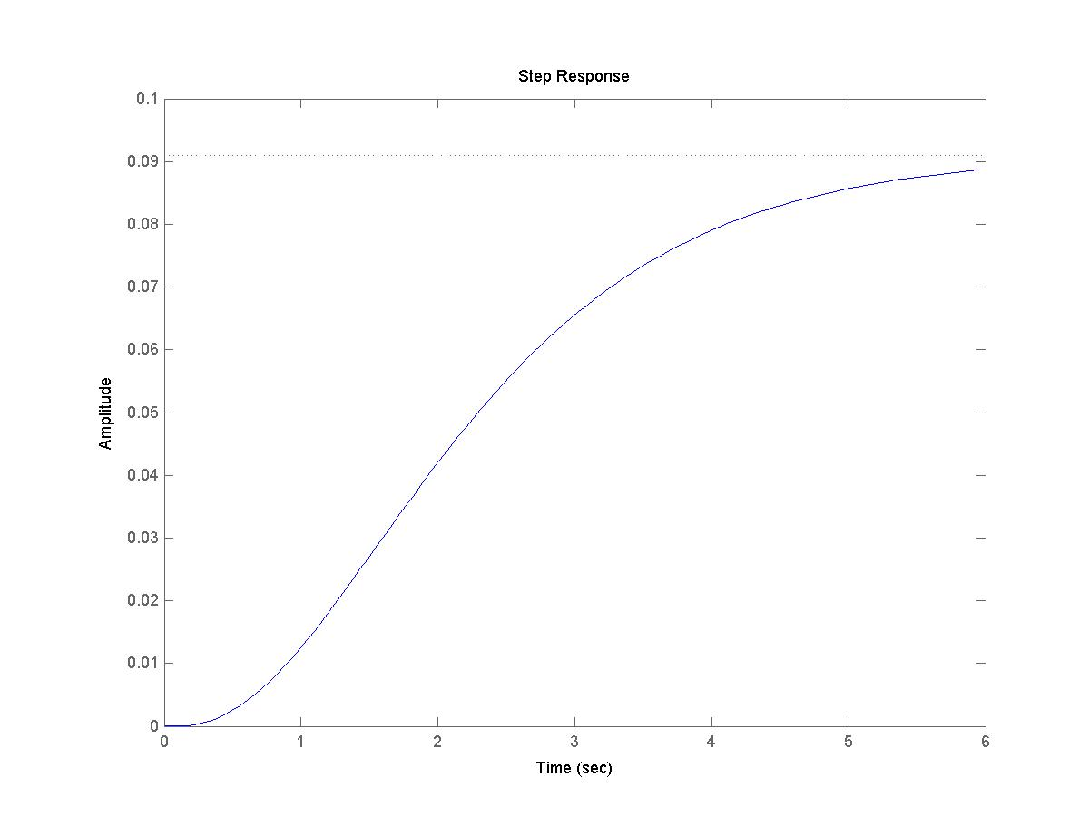
Fig. 1 Step response of Example 1
From Fig. 1, it can be seen that it requires about 6 seconds for the system to get close to steady state, therefore, the variable of “end time” can be 6 if the “start time” is 0. “SampleLength” can be 0.1. Therefore, “Tspan” = [0 6 0.1].

Model reduction demonstration
The following steps (a), (b), (c) are included in the file “lin_test.m”, step (e) is shown in file “lin_test_comparison.m”.

(a) compute empirical controllability gramian
The input arguments are:
“ParaVector” = [1 3 1 2 1000], “Tspan” = [0 6 0.1], “Cm” = 0.1, s = size(Cm) = 1, flag = 0.
Then the controllability gramian can be computed as:
yhat = ctrl_gram_cov (OdeFcn, Tspan, ParaVector, Cm, flag) for the scaled system.
yhat = ctrl_gram_cov_unscaled (OdeFcn, Tspan, ParaVector, Cm, flag) for the unscaled system.
If the controllability covariance matrix is desired, then the “flag” needs to be set to any integer other than 0, for instance, “flag” = 1.
The result of the (empirical) controllability gramian for the unscaled system is
$${\text{Ctrl}}_{{\text{gram}}_{\text{unscaled}}}= \begin{aligned}\left[\text{ 1}\text{.}\text{0053 0}\text{.}\text{3232 0}\text{.}\text{0109} | \right]\left[\text{ 0}\text{.}\text{3232 0}\text{.}\text{2911 0}\text{.}\text{0190} | \right] \\ \end{aligned}$$
By use of the MATLAB command “gram”, the controllability gramian for the unscaled system is [command: gram(sys(A,B,C,D), ‘c’)]
$${\text{Ctrl}}_{{\text{gram}}_{{\text{unscaled}}_{\text{matlab}}}}= \begin{aligned}\left[\text{ 1}\text{.}\text{0000 0}\text{.}\text{3226 0}\text{.}\text{0108} | \right]\left[\text{ 0}\text{.}\text{3226 0}\text{.}\text{2933 0}\text{.}\text{0191} | \right] \\ \end{aligned}$$
The result of the (empirical) controllability gramian for the scaled system is
$${\text{Ctrl}}_{{\text{gram}}_{\text{scaled}}}= \begin{aligned}\left[\text{ 0}\text{.}\text{9995 0}\text{.}\text{3561 0}\text{.}\text{1199} | \right]\left[\text{ 0}\text{.}\text{3561 0}\text{.}\text{3525 0}\text{.}\text{2299} | \right] \\ \end{aligned}$$
And by use of the MATLAB command “gram”, the controllability gramian for the scaled system is [command: gram(sys($\tilde{A},\tilde{B},\tilde{C},\tilde{D}$), ‘c’)]
$${\text{Ctrl}}_{{\text{gram}}_{{\text{scaled}}_{\text{matlab}}}}= \begin{aligned}\left[\text{ 1}\text{.}\text{0000 0}\text{.}\text{3548 0}\text{.}\text{1183} | \right]\left[\text{ 0}\text{.}\text{3548 0}\text{.}\text{3548 0}\text{.}\text{2309} | \right] \\ \end{aligned}$$
It can be seen that Ctrl_gram_unscaled and Ctrl_gram_unscaled_matlab return results that are very close to one another. There only exist a very small difference between them. Similarly, the results returned by Ctrl_gram_scaled and Ctrl_gram_scaled_matlab are also very close.

- compute observability gramian
With all input arguments already known, the observability gramian is:
xhat = obsv_gram_cov (OdeFcn, Tspan, ParaVector, Cm, OutputIndex, xss, flag) for scaled system, or
xhat = obsv_gram_cov_unscaled (OdeFcn, Tspan, ParaVector, Cm, OutputIndex, uss, xss, flag) for unscaled systems.
The result returned for the observability gramian for the unscaled system is
$${\text{Obsv}}_{{\text{gram}}_{\text{unscaled}}}= \begin{aligned}\left[\text{ 0}\text{.}\text{0005 0}\text{.}\text{0009 0}\text{.}\text{0079} | \right]\left[\text{ 0}\text{.}\text{0009 0}\text{.}\text{0021 0}\text{.}\text{0235} | \right] \\ \end{aligned}$$
By use of the MATLAB command “gram”, the observability gramian for unscaled system is [command: gram(sys(A,B,C,D), ‘o’)]
$${\text{Obsv}}_{{\text{gram}}_{{\text{unscaled}}_{\text{matlab}}}}= \begin{aligned}\left[\text{ 0}\text{.}\text{0005 0}\text{.}\text{0010 0}\text{.}\text{0079} | \right]\left[\text{ 0}\text{.}\text{0010 0}\text{.}\text{0022 0}\text{.}\text{0238} | \right] \\ \end{aligned}$$
The result of observability gramian for the scaled system is
$${\text{Obsv}}_{{\text{gram}}_{\text{scaled}}}= \begin{aligned}\left[\text{ 0}\text{.}\text{0019 0}\text{.}\text{0034 0}\text{.}\text{0029} | \right]\left[\text{ 0}\text{.}\text{0034 0}\text{.}\text{0071 0}\text{.}\text{0078} | \right] \\ \end{aligned}$$
And by use of the MATLAB command “gram”, the observability gramian for the scaled system is [command: gram(sys($\tilde{A},\tilde{B},\tilde{C},\tilde{D}$), ‘o’)]
$${\text{Obsv}}_{{\text{gram}}_{{\text{scaled}}_{\text{matlab}}}}=\begin{aligned}\left[\text{ 0}\text{.}\text{0019 0}\text{.}\text{0035 0}\text{.}\text{0029} | \right]\left[\text{ 0}\text{.}\text{0035 0}\text{.}\text{0072 0}\text{.}\text{0079} | \right] \\ \end{aligned}$$
It can be seen that Obsv_gram_unscaled is quite close to Obsv_gram_matlab considering the assumptions made above. The same is true for the commands Obsvl_gram_scaled and Obsv_gram_scaled_matlab.

(c) Compute balanced transformation matrix
After the controllability gramian yhat and observability gramian xhat are obtained, the transformation matrix can be computed by the following command:
[Trans, invTrans, Wc, Wo, svd_Wc, svd_Wo] = bal_realization(yhat, xhat, n)
The result returned for the transformation matrix for the unscaled system is:
$${\text{Trans}}_{\text{unscaled}}= \begin{aligned}\left[\text{ -0}\text{.}\text{0760 -0}\text{.}\text{1808 -2}\text{.}\text{6316} | \right]\left[\text{ 0}\text{.}\text{0886 0}\text{.}\text{0983 -2}\text{.}\text{9249} | \right] \\ \end{aligned}$$
By use of the MATLAB command “balreal”, the transformation matrix for the unscaled system is [command: balreal(sys(A,B,C,D))]
$${\text{Trans}}_{{\text{unscaled}}_{\text{matlab}}}= \begin{aligned}\left[\text{ -0}\text{.}\text{0773 -0}\text{.}\text{1845 -2}\text{.}\text{5300} | \right]\left[\text{ 0}\text{.}\text{0887 0}\text{.}\text{0859 -2}\text{.}\text{7758} | \right] \\ \end{aligned}$$
These quantities are very close.
Also, for the scaled system, the result is:
$${\text{Trans}}_{\text{scaled}}= \begin{aligned}\left[\text{ -0}\text{.}\text{1071 -0}\text{.}\text{2322 -0}\text{.}\text{3396} | \right]\left[\text{ -0}\text{.}\text{1256 -0}\text{.}\text{1270 0}\text{.}\text{3753} | \right] \\ \end{aligned}$$
By use of the MATLAB command “balreal”, the transformation matrix for the scaled system is [command: balreal(sys($\tilde{A},\tilde{B},\tilde{C},\tilde{D}$))]
$${\text{Trans}}_{{\text{scaled}}_{\text{matlab}}}= \begin{aligned}\left[\text{ -0}\text{.}\text{1093 -0}\text{.}\text{2372 -0}\text{.}\text{3253} | \right]\left[\text{ 0}\text{.}\text{1254 0}\text{.}\text{1105 -0}\text{.}\text{3569} | \right] \\ \end{aligned}$$
These quantities are also very close.despite the signs. The signs are not a problem as long as they are consistent in the whole procedure.
By comparing the results computed by the presented code with those computed directly by MATLAB, it can be seen that our code is applicable to linear system and the nonlinear gramians have reduced to linear gramians in as the system under study is linear. One point which should be mentioned is that the code for unscaled systems is used to compute these quantities and compared them with the results returned by MATLAB. However, it is important to scale the system so that the importance of each state can be compared based on a uniform standard. Therefore, the code for a scaled system should generally be used to compute gramians.

(d) Generate the reduced order system
If the odefile of the scaled system is as follows,

-----------------------------------------------------------
function xdot = lin_example_scaled(t,x)
global ud uss xss a b c d;
x = diag(xss)*x;
u = diag(uss)*ud;
xdot = a*x + b*u;
xdot = diag(1./xss)*xdot;
-----------------------------------------------------------

then the reduced order system can be obtained by modifying the above ode function:

-----------------------------------------------------------
function xdot = lin_example_scaled_red(t,x)
global ud uss xss a b c d red_n Trans invTrans n;
x=diag(xss)*invTrans*x;
u = diag(uss)*ud;
xdot = a*x + b*u;
xdot = diag(1./xss)*xdot;
xdot(1:red_n,1) = Trans(1:red_n,:)*xdot;
xdot(red_n+1:n,1) = zeros(n - red_n,1);
-----------------------------------------------------------

In this ode function, Trans refers to the balanced transformation matrix, invTrans is its inverse, red_n is the number of retained states.

(e) Test the reduced order systems by comparing step response with the full-order system
Run the file “lin_test_comparison.m” to see this demonstration.
It should be noted that when the reduced-order system is integrated, the initial value should be transformed by use of the balanced transformation matrix (initvalue = Trans*ones(n,1);). And the output should be transformed back to the original coordinate (y = (invTrans*y')').
For instance,

-----------------------------------------------------------
% retaining 2 states
red_n = 2;
% initial states
initvalue = Trans*ones(n,1);
% integrate the reduced system
[t, y] = ode15s('lin_example_scaled_red',[0 10], initvalue);
y = (invTrans*y')';
-----------------------------------------------------------

A comparison between the reduced system and the full order system is shown in Fig. 2.
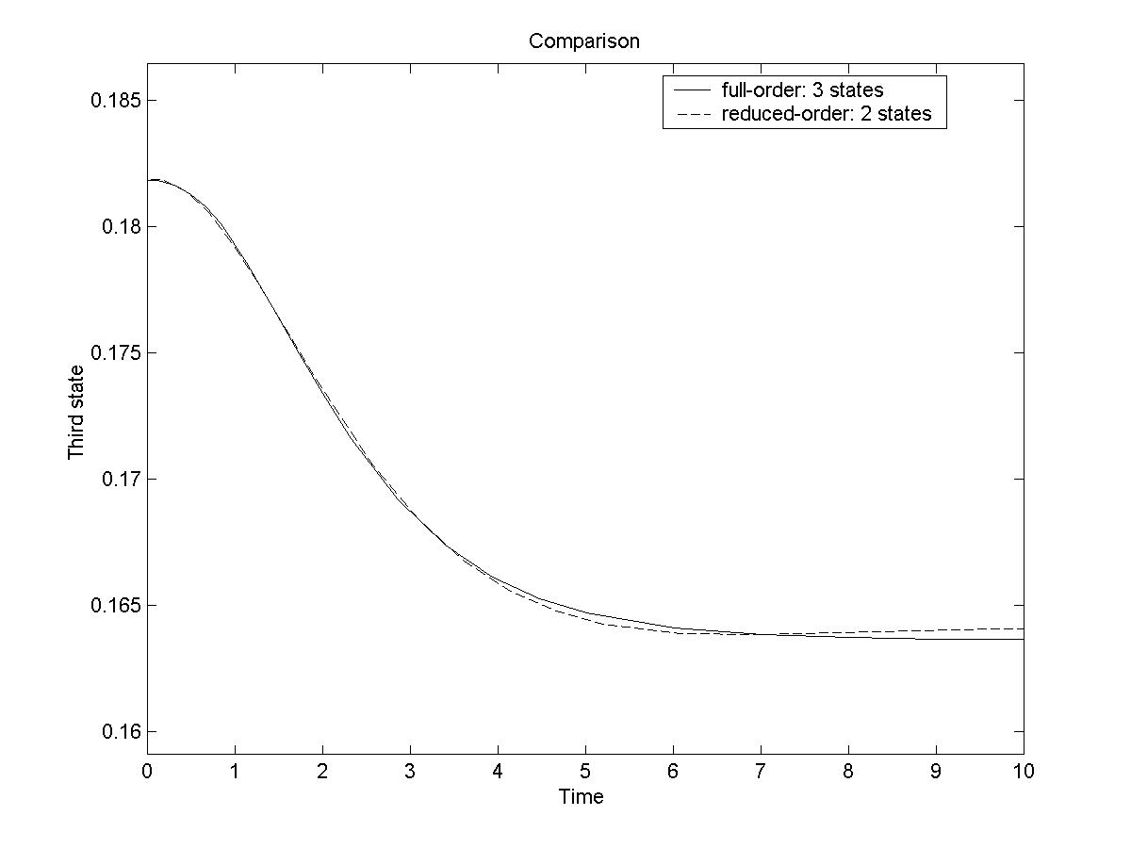
Fig. 2 Demo_1 Result

Example 2: Distillation column model
Consider a distillation column with 30 trays for the separation of a binary mixture. The column has 32 states and is assumed to have a constant relative volatility of 1.6, and symmetric product compositions. The feed stream is introduced at the middle of the column on stage 17 and has a composition of xF = 0.5. Distillate and bottoms purities are xD = 0.935 and xB = 0.065, respectively. The reflux ratio is set to 3.0 and can be controlled and the purity of the distillate is measured.
The input arguments are:
“Tspan” = [0 125 1], “ParaVector” = [1 32 1 2 1000], cm = 0.1, uss = 3, OutputIndex = 1, flag = 0.
xss = [0.93541941157872
0.90052553056021
0.86229644186085
0.82169939140984
0.77999078264854
0.73857167234648
0.69880489484850
0.66184251976399
0.62850776220669
0.59925268627060
0.57418566680025
0.55314421560916
0.53578453438249
0.52166549782463
0.51031494886053
0.50127506214214
0.49412897870388
0.48544972899159
0.47420288473721
0.45980255225419
0.44164493109501
0.41918698092364
0.39206347037950
0.36023104831510
0.32410540528069
0.28463655998183
0.24326615176966
0.20174466282063
0.16184801596532
0.12508549255782
0.09249569166350
0.06458058721594].
$${\text{Svd}}_{\text{scaled}}= \begin{aligned}\left[\text{ 0}\text{.}\text{11599} | \right]\left[\text{ 0}\text{.}\text{0048545} | \right]\left[\text{ 0}\text{.}\text{0007854} | \right]\left[\text{ 0}\text{.}\text{00012426} | \right]\left[2\text{.}\text{1448e-005} | \right] \\ \end{aligned}$$

The result is shown in Fig. 3.
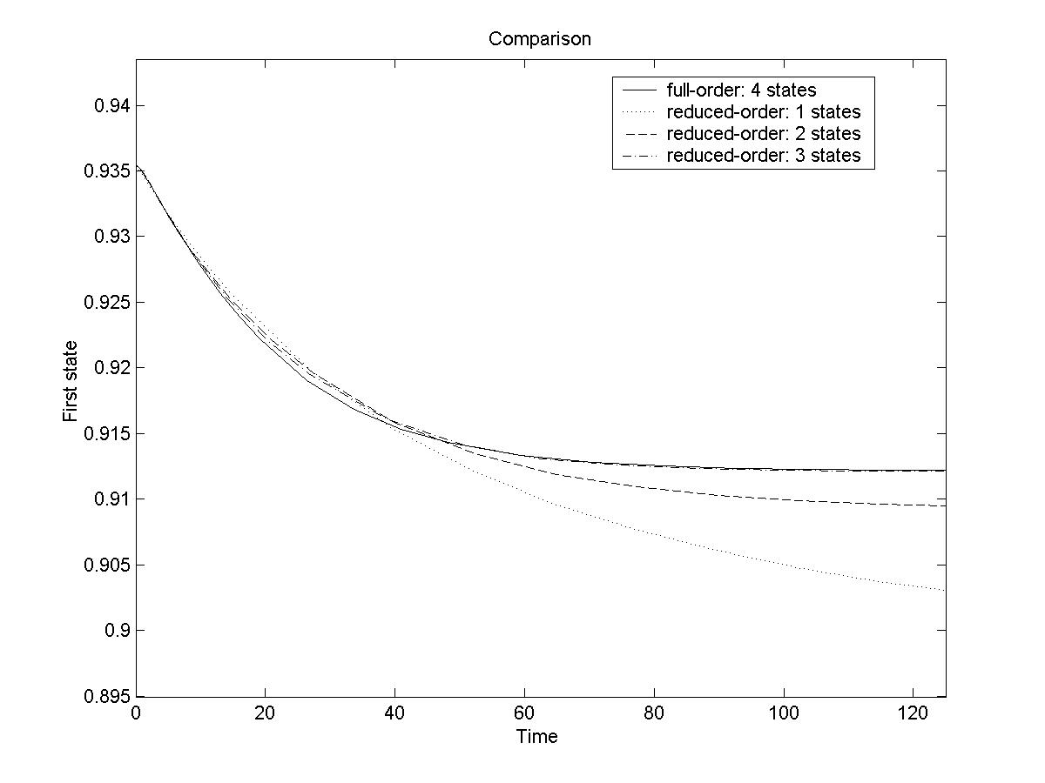
Fig. 3 Demo_2 result

Example 3: a CSTR system
This example is a system of two CSTRs in series, which was presented in the nonlinear process control book edited by Henson and Seborg [5]. The model has four states, one input which is the coolant flow rate $q_{c}$ and one output, the effluent concentration from the second tank. The input has a nominal value of $q_{c0}=\text{100}L\text{/min}$.
Since this system is not control-affine, the empirical gramian cannot be obtained. In this case, the covariance matrices are computed.
The input arguments are:
“Tspan” = [0 10 0.1], “ParaVector” = [1 4 1 2 1000], cm = 0.01, uss = 100, xss = [ 0.0882 441.2193 0.0053 449.4746]^{T}, OutputIndex = 3, flag = 1.
The results for the scaled system are:
$$\text{Ctrl}\text{_cov}{\text{ariance}}_{\text{scaled}}= \begin{aligned}\left[\text{ 4}\text{.}\text{3026 -0}\text{.}\text{1809 7}\text{.}\text{8843 -0}\text{.}\text{1515} | \right]\left[\text{ -0}\text{.}\text{1809 0}\text{.}\text{0078 -0}\text{.}\text{3192 0}\text{.}\text{0060} | \right]\left[\text{ 7}\text{.}\text{8843 -0}\text{.}\text{3192 15}\text{.}\text{3951 -0}\text{.}\text{3073} | \right] \\ \end{aligned}$$
$$\text{Obsv}\text{_cov}{\text{ariance}}_{\text{scaled}}= \begin{aligned}\left[\text{ 0}\text{.}\text{0000 0}\text{.}\text{0011 0}\text{.}\text{0000 0}\text{.}\text{0002} | \right]\left[\text{ 0}\text{.}\text{0011 0}\text{.}\text{0425 0}\text{.}\text{0000 0}\text{.}\text{0087} | \right]\left[\text{ 0}\text{.}\text{0000 0}\text{.}\text{0000 0}\text{.}\text{0000 -0}\text{.}\text{0000} | \right] \\ \end{aligned}$$
$${\text{Trans}}_{\text{scaled}}= \begin{aligned}\left[\text{ 0}\text{.}\text{0241 1}\text{.}\text{2795 -0}\text{.}\text{0073 0}\text{.}\text{3472} | \right]\left[\text{ 0}\text{.}\text{0732 2}\text{.}\text{5367 0}\text{.}\text{0236 0}\text{.}\text{2518} | \right]\left[\text{ 0}\text{.}\text{1291 1}\text{.}\text{9599 -0}\text{.}\text{0054 1}\text{.}\text{0097} | \right] \\ \end{aligned}$$
$${\text{Svd}}_{\text{scaled}}= \begin{aligned}\left[\text{ 0}\text{.}\text{0134} | \right]\left[\text{ 0}\text{.}\text{0028} | \right]\left[\text{ 0}\text{.}\text{0007} | \right] \\ \end{aligned}$$

The result is shown in Fig. 4.
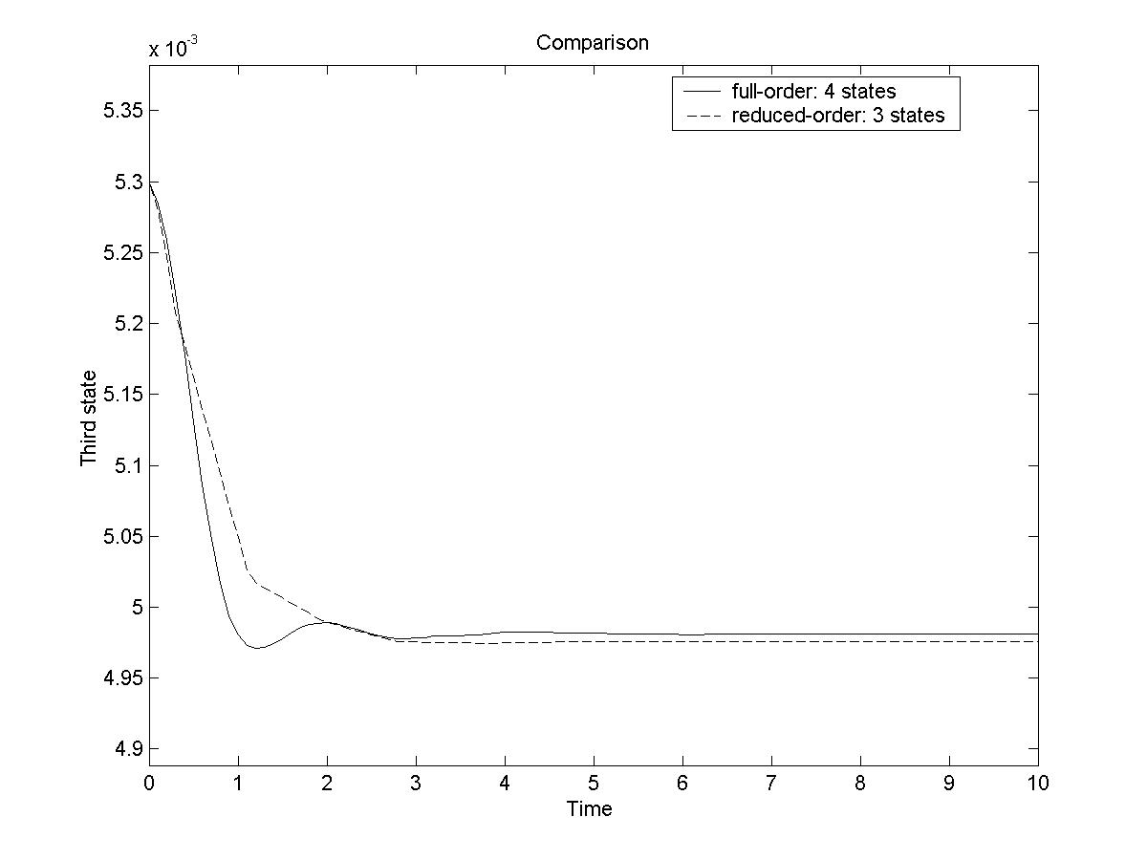
Fig. 4 Demo_3 result

Files descriptions

For “functions”:
ctrl_gram_cov.m function to compute controllability gramian or covariance matrix for scaled systems
ctrl_gram_cov_unscaled.m function to compute controllability gramian or covariance matrix for unscaled systems
obsv_gram_cov.m function to compute observability gramian or covariance matrix for scaled systems
obsv_gram_cov_unscaled.m function to compute observability gramian or covariance matrix for unscaled systems
bal_realization.m function to compute balancing transformation

For “Demo1”:
lin_example.m the ODE function for the unscaled system
lin_example_scaled.m the ODE function for the scaled system
lin_example_scaled_red.m the ODE function for the reduced scaled systems
lin_example_matrix.mat data saved for the balanced system
lin_test.m run program1, to compute gramians and balanced transformation
lin_test_comparison.m run program2, to compare the reduced order models to the full order system

For “Demo2”:
distill.m the ODE function for the distillation column (scaled)
distill_red.m the ODE function for the reduced model
non_example1_matrix.mat data saved for the balanced system
nonlinear_test1.m run program1, to compute gramians and balanced transformation
nonlinear_test1_comparison.m run program2, to compare the reduced order models to the full order system

For “Demo3”:
cstr_unscaled_non.m the ODE function for the unscaled CSTR model
cstr_scaled_non.m the ODE function for the scaled CSTR model
cstr_scaled_non _red.m the ODE function for the reduced model
non_example2_matrix.mat data saved for the balanced system
nonlinear_test2.m run program1, to compute covariance matrices and balanced transformation
nonlinear_test2_comparison.m run program2, to compare the reduced order models to the full order system

Conclusions
This documentation presents a tutorial on how to perform nonlinear model reduction via balanced truncation using the routines presented on the web site. Basic principles and descriptions of routine functions are presented. Several case studies are used to demonstrate these routine functions, both for linear and nonlinear systems.

References

- S. Skogestad and I. Postlethwaite, Multivariable feedback control. John Wiley & Sons, New York, 1997.
- S. Lall, J.E. Marsden, and S. Glavaski, Empirical model reduction of controlled nonlinear systems. IFAC World Congress, 1999.
- J. Hahn and T.F. Edgar, An improved approach to the reduction of nonlinear models using balancing of empirical gramians, Computers Chem. Engng. 26, 1379-1397, 2002.
- J. Hahn and T.F. Edgar, Balanced approach to minimal realization and model reduction of stable nonlinear systems, I&EC Research 41 (24), 2204-2212, 2002.
- M.A. Henson, D.E. Seborg, Feedback linearizing control, In Nonlinear Process Control, 149-231, M.A. Henson & D.E. Seborg (eds), Upper Saddle River, N.J, Prentice Hall PTR, 1997.

